Flexible Operation of Renewable Fuel Production Navigating Long-Term Offtake Contracts
Frederik Skou Fertin, DTU Management, +45 61143148, fskfe@dtu.dk
Farzaneh Pourahmadi, DTU Wind, farpour@dtu.dk
Ioannis Kountouris, Blue Power Partners, iko@bluepp.dk
Dogan Keles, DTU Management, dogke@dtu.dk
DTU: Technological University of Denmark
Overview
Renewable fuel production presents itself as a pathway to decarbonize hard-to-electrify sectors such as aviation and long-haul shipping. A high demand for electricity and consequent high production costs, however, challenges the business cases of energy projects looking to convert renewable electricity into green fuels. Along with high operational costs of fuel production, the electricity consumption also introduces exposure to long- and short-term volatility and uncertainty in market prices. To stabilise cash flows and secure financing, the renewable fuel producer negotiates long-term contracts for both power procurement and fuel offtake.
Securing contracted power and contracted offtake can enable investment in renewable fuel production by reducing risk. However, there is a need to assess the appropriate degree to which a renewable fuel producer should rely on contractual arrangements and hedging, which decreases the operational flexibility of the renewable fuel plant.
From a private actor perspective, it is desirable to maintain operational flexibility to allow capture of future revenue opportunities. From an energy systems perspective, it is crucial that power-to-X (PtX) technologies can operate flexibly and follow the production profile of variable renewable electricity as to not strain the system and produce non-sustainable fuels.
This poses the overarching research questions of this study: How can long-term contractual offtake commitments be optimally integrated into the daily operational planning of a renewable fuel plant? How can contracts be designed to enable flexible operation of renewable fuel production?
Methods
The research questions are addressed through a structured methodological framework. The study develops and deploys a rolling horizon decision-making framework motivated by day-to-day trading decisions in the day-ahead electricity market. A stochastic time series model is developed to forecast short-term uncertainty and long-term variability in renewable generation and electricity market prices. Second, a valuation methodology is formulated to estimate the internal strike price (ISP) of renewable fuel production, providing a measure of the opportunity cost of fuel production relative to electricity sales. Third, three alternative planning strategies to meet long-term contractual obligations are formulated and validated to benchmark the developed methodology. The methodology is applied to a case study, supported by scenario analysis of alternative offtake contract structures, assessing the impact of contractual and operational design choices on renewable fuel production profitability.
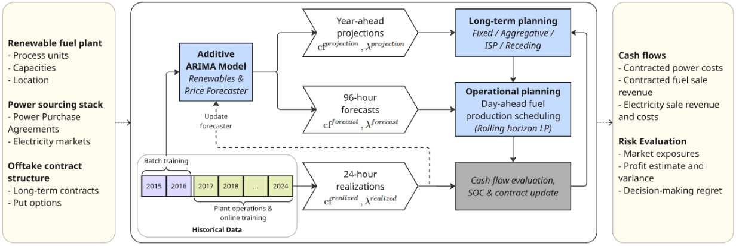
Figure 1: Methodological framework. Given a renewable fuel plant and contract structures, the methodology enables identification of optimal operational scheduling of fuel production, estimates cash flows and the risk profile of the contractual setup.
This study builds on the existing literature by addressing limited tools to navigate offtake contracts in the operational planning of renewable fuel production. The methodological contribution of the study is based on the development of a heuristic utilizing a production-weighted price duration curve to accurately identify the opportunity cost of selling electricity for a renewable fuel producer. This opportunity cost is defined as the internal strike price (ISP), which the fuel producer trades electricity based on. The proposed heuristic (ISP) is compared to three approaches known from the literature: a fixed hourly production schedule (Fixed), a rolling horizon model with the long-term fuel production included through an aggregate time step (Aggregative), a receding horizon model with all hours of the year included explicitly in the linear model formulation (Receding). Finally, the hindsight optimal dispatch is also evaluated to set an upper benchmark for the operational planning.
Results
A case study of a large-scale Portuguese hydrogen and ammonia production plant (250 MW electrolyzer) is used to validate the operational planning tool. 50% of the ammonia production capacity is contracted with an annual commitment. The Fixed long-term planning strategy handles this contractual setup by running the ammonia synthesis unit at a 50% load continuously, whereas the other planning strategies navigate the long-term contract flexibly by planning production during low electricity price hours. The study finds that compliance of long-term contract obligations is achieved through all four production planning strategies with the receding horizon model obtaining the highest earnings of 78.3% of optimal earnings. However, the difference between the ISP guided operational planning and the Receding model is only 0.3%-point, whereas the computational costs of the Receding planning strategy is around 14 times higher. This highlights that the estimated opportunity cost efficiently allows the day-to-day production planning to navigate the long-term offtake contracts. The Aggregative decision-making model also improves the earnings significantly from the Fixed schedule. However, it falls short by not being able to fully integrate the opportunity cost of electricity sales in the day-to-day fuel production planning.
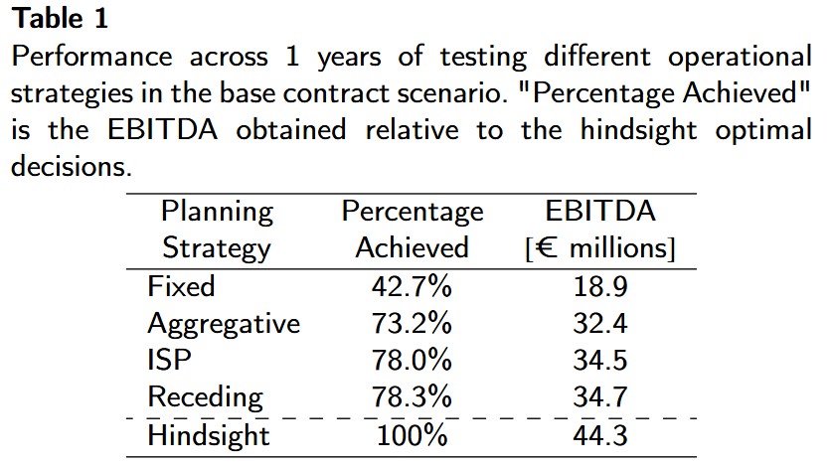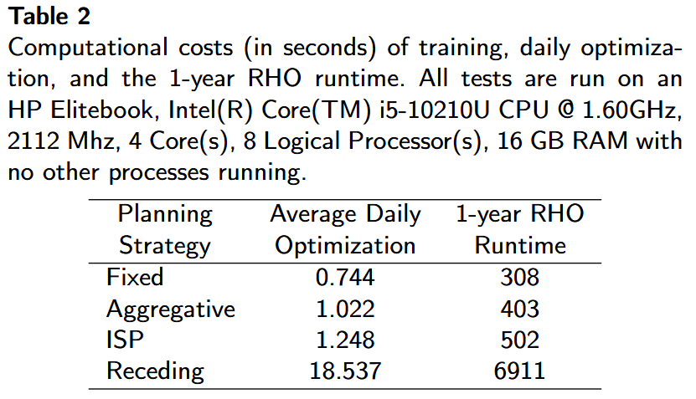
Continuing to utilize the ISP planning strategy, the study investigates the potential value of a flexible offtake contract. Utilizing the developed framework, we show that allowing a buffer volume on the annual contracted volume of ±10% allows for a profit increase of 7.9% using the limited foresight ISP guided operational planning. This both enables the PtX technology to operate more flexibly but also enables the fuel producer to lower the production costs of their products, facilitating decarbonization.
Conclusions
The study concludes that long-term contractual commitments can be integrated in the daily operational planning of a fuel producer. By accurately estimating the dynamic opportunity cost of electricity sales, the long-term contracts are navigated efficiently allowing flexible operations while staying compliant.
The computational cost of the planning strategies is kept relatively low by keeping a fully linear model formulation in this study. However, future work could look to more accurately model startup costs and operational states of the plant units, which would make it intractable to utilize a model formulation approach like the Receding horizon model.
The study also highlights the value of allowing fuel producers to negotiate offtake contracts with buffer volumes. Future work should look more into the trade-offs for the stakeholders and the potential value of the contract flexibility for the energy system.

